Why Are Vaccine Injured Patients Silenced?

How a decade of propaganda turned us against each other

A MIDWESTERN DOCTOR
SEP 23, 2023
Likes: 197

Comments: 116

Restacks: 15

One of the cruelest things about being injured by a pharmaceutical is the degree to which doctors will deny the idea that the injury happened (as acknowledging it requires them to accept the shortcomings of the medical model they’ve invested their lives into). This denial is known as medical gaslighting and it is often so powerful that friends and family members of the patient will adopt the reality asserted by those doctors and likewise gaslight the injured patient. I’ve lost count of how many times I’ve seen this tragedy transpire in my immediate circle and one of my missions here has been to bring awareness to medical gaslighting and explain why it always happens (i.e., it was discussed in detail here).
I mention all of that because I recently saw a story that was shared by Pierre Kory on Twitter and realized it touched upon many of the reasons why I’ve invested myself into writing here [along with one of the more unique symptoms of COVID vaccine injuries]:

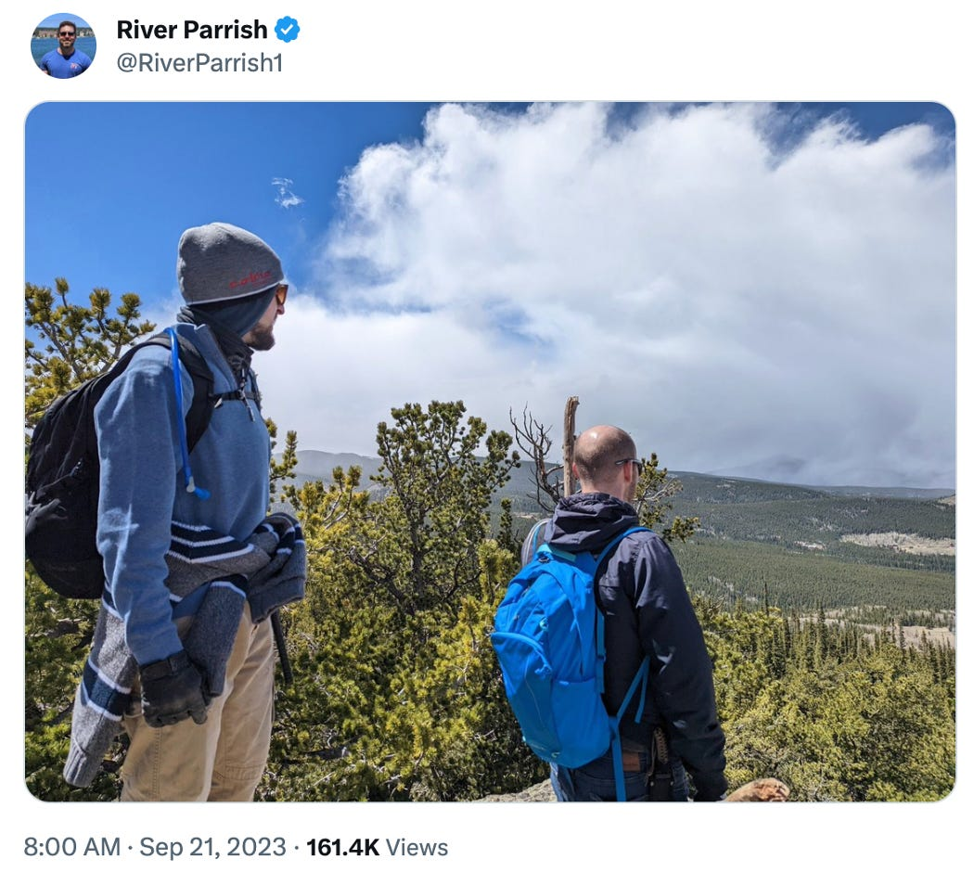

A hiking buddy of mine who had noticeably and suddenly stopped doing the more strenuous 14,000ft hikes a couple of years ago called me and made a confession:
He got myocarditis from his second mRNA shot. Listening to him describing being alone on a trail run and suddenly having chest pains and trouble breathing was horrifying. He was afraid he was going to die alone. He's a marathoner and highly active, in his mid 30s.
The worst part: He was afraid to tell me or anyone in his friend group.
His literal quote:
"I saw how Oz [his best friend] and especially his fiance [a med school graduate in residency who is super attached to the establishment covid narrative] were talking about the antivaxxers, and I felt like if I talked about it with any of them, I would have hurt Oz's relationship. I also felt like Kristen [a mutual friend of ours] would have judged me and stopped hanging out. I just kept it quiet. But yeah man, I'm still having a hard time with the 14ers, and my run times are all way down."
This is a photo of him (on the left, not showing his face out of respect for his privacy) on our last hike where we were only at 10,000ft altitude, and at the time I had noticed he was struggling, but when we asked him about it, he said he was "hungover". He wasn't. It was about 10 month after the myocarditis, and he was hiding it from us.
Self-censorship is perhaps the most horrifying aspect of this. None of us should find out years later that our friends had to be hospitalized. The fact that he felt he had to hide it is horrifying.
He is an incredibly smart and driven guy, and he bluntly told me that he "knows, deep down, that if I said anything about this publicly, I'd be flushing my career down the toilet. I work in the software industry in Boulder. I know what will happen if I say something."
When I told him that I believed him, and told him about my mother-in-law and my neighbor, he obviously felt a huge sense of relief. He was afraid that I was going to judge him for the crime of telling me about a medical side-effect. Ironically, his first job out of college was working for a pharma company, specifically on a new statin.
His description of the science on statins, and the things they were and were not allowed to study on statins, was horrifying. His exact words, which echoed what I've heard @BretWeinstein say:
"Working there, the entire culture is so messed up man. Like, the way they think is 'we're going to market this, now you go and make sure we can get it approved, and it was obvious that without studying anything, they already were making it clear that we WILL get it approved, and your job is to make sure you design the studies to make that happen.' Dude, they don't care about people at all. It's just numbers to them."
What have we done? There needs to be a reckoning for the regulatory capture of the CDC/FDA, and the current administration's obviously political taint to the approval process. The current booster that the US is pushing on the age group 6 months and up is only approved for those over 65 in the UK and Europe. There is no scientific explanation for this discrepancy. There is something wrong.
The Forgotten Side of Medicine is a reader-supported publication. To receive new posts and support my work, please consider becoming a free or paid subscriber.
Subscribed

Altitude Sickness
One of the symptoms that (more ill) vaccine injured patients frequently report to me is an inability to tolerate higher altitudes (e.g., one patient told me their primary goal was to be able to go to the mountains again). Throughout my career, I have come to associate this symptom with an impaired physiologic zeta potential (which causes blood cells to clump together forming a sludge of sorts that obstructs the smaller vessels) and I have periodically found that restoring the physiologic zeta potential improves this inability to tolerate higher altitudes.
At the start of COVID-19 (a disease, which like COVID vaccine injuries I associate with pathological changes to the physiologic zeta potential), many doctors suspected COVID-19 might be related to altitude sickness as many of the symptoms overlapped (and in turn some used the same medications used for altitude sickness to treat COVID-19). Since then, it has also been observed that individuals who recovered from COVID sometimes have difficulty with visiting high altitudes and that individuals living at high altitudes have greater difficultly with long COVID.
One of the most analogous conditions to blood sludging is sickle cell anemia, a genetic disease where in certain conditions, due to their genetically abnormal shape, blood cells will sickle together and obstruct flow through the blood vessels they are in—which when severe enough is known as a sickle cell crisis (and frequently requires hospitalization). Sickle cell crises have been repeatedly observed to trigger at high altitudes (often in association with a splenic infarction—something which has also been repeatedly observed in individuals with COVID vaccine injuries). Similarly, the altitudes sickle cell patients can tolerance are similar to what I’ve seen with other chronic illnesses characterized by a poor physiologic zeta potential:
Altitude exposures were divided into airplane travel and mountain visits, and the latter subdivided into stays at 4,400 or 6,320 ft. The average risk of crisis was higher for both groups while in the mountains (37.9 percent and 56.6 percent, respectively) than it was during airplane travel (10.8 percent and 13.5 percent, respectively). The latter group had more splenic crises than the former group and also had a greater risk at 6,320 ft (65.9 percent) than at 4,400 ft (20.0 percent). Patients with sickle cell disease are at high risk of crisis in the mountains, and we advise those with intact spleens to breathe supplemental oxygen during air travel.
Lastly, I’m not sure if this is related, but I’ve previously worked with competitive free-divers (which requires one to hold their breath for long periods) and I’ve found that improving their microcirculation increases the length of time they can hold their breath underwater. However, I haven’t seen any of those patients since COVID started so I can’t state with certainty that a significant disruption in microcirculation from the spike protein would also impair this aspect of the respiratory system.

Seizing Power
In every society, there will always be people who thirst for power and will do whatever they can to get it, irrespective of the human harms or costs it creates. For example, consider this timeless quote from Aldous Huxley:
[T]he passion for power is one of the most moving passions that exists in man. And, after all, all democracies are based on the proposition that power is very dangerous, and that it’s extremely important not to let any one man or any one small group have too much power for too long a time. After all, what are the British and American constitutions, except devices for limiting power? All of these new devices [television, radio, etc.] are extremely efficient instruments for the imposition of power by small groups over larger masses.”
I (and many others) believe this lust for power is quite misguided because:
•The desire for power typically emerges because one’s internal world is a mess (in otherwords they don’t feel good) and the individual has come to believe that getting power will alleviate their angst. In reality, this never works (as the problem is not due to their external world), and power like many other things becomes an addiction where they crave more and more and more of it—yet no matter how much they get, they always need more. This is why we now have many people who have more money than they can ever possibly spend in a lifetime, but nonetheless, they voraciously try to gobble everything else up regardless of how much it hurts the world around them.
•Power is a double-edged sword. The more of it you have, the more you have to do to maintain it, and the more you exercise control over others, the more they exercise control over you. I personally believe unless you have a very specific goal you are trying to enact (e.g., ending the vaccination fiasco), the loss of your own personal freedom greatly outweighs any benefit you get from seizing power.
•Anytime you do something which harms others, it creates negative karma that will eventually come back to you. This is always an issue, but in a position of power that backlash is much greater.
Sadly, the above issues are rarely recognized, and the suffering those seeking power create both for others and themselves are a recurring theme throughout history. This is why I believe it is so important to have a government with rules constraining its power (so those who inevitably take the reins of power are less able to hurt the populace). Likewise, it’s why I’ve focused on explaining the methods these people always use to grab power as my hope is that by doing so, it can help you to recognize how this is being done to you and make you immune to it.
Note: when challenging people who have differing viewpoints from your own, it is critical to come from an open space where you are are trying to share your perspective and hear theirs. If you instead have the goal of proving them wrong (which many people do since they wish to be right and have power over others), that will cause both parties to close down and typically prevents anything productive from occurring. When I speak with people who are trying to red-pill their family members, this is one by far the most common reason why they fail to get through to them and understandably become immensely frustrated.

The Scalability of Power
In business, one of the challenges every endeavor faces is if it can be ramped up and sold to a larger number of people. This is why the pharmaceutical industry for example focuses on drugs that can be sold for common conditions, whereas it almost never creates treatments for very rare conditions.
In addition to having access to a larger market, another major challenge is being able to ensure you can actually provide your product to that increasing market. Within integrative medicine for example, I know numerous extraordinary physicians who can often produce miraculous results for patients no one else has been able to help. However, in many cases, those successes require the physician to have a great deal of experience, ingenuity, and perceptivity—which is a major problem for patients because physicians with that skillset are quite rare and hence not available for many who need them.
Likewise, over the last few years, I’ve treated numerous vaccine injured patients colleagues referred to me because I feel a deep conviction these people need to be helped. At the same time, one of the major things I’ve struggled with is that these conditions are often so complex and variable that while I can typically treat them, its extremely time consuming (thereby taking me away from the less complex patients I also have an obligation to) and it is hence for all practical purposes impossible for my team to help more than a microscopic fraction of the people out there who desperately need help. This essentially is why I’ve put so much effort into trying to make some of what I’ve found is necessary for treating these patients be available here as it provides a means for me to have some degree of scalability for helping these patients.
In the case of “power” an analogous issue emerges; if someone wants to dominate others, they need to have agents to enforce that domination. On a small scale, this is feasible (e.g., one person ruling over their family with an iron fist) but on a larger level its not as there are simply not enough enforcers available to control the entire population (e.g., the United States has never been able to deploy an army that was large enough to control a foreign country that did not want to be occupied).
To “solve” this challenge, those in power instead make use of a variety of tools which are much more affordable than what would be needed to directly control each member of the society. Soft power, in turn, takes a variety of forms. For example, one well-known tactic we still see used to this day is to make a public example out of anyone who challenges someone’s power (e.g., by executing them or by giving them a lengthy and unjust prison sentence), as it makes everyone who witnesses it reluctant to challenge the power hungry individual.
Another common approach is to pit those you wish to control against each other so that rather than being united against obvious tyranny, they tear each other down for the benefit of the ruling class. Since humans have always been quite tribal, this tactic works and has been used by psychopaths throughout history. For example, much of what we are witnessing in the modern crusade against racism almost perfectly mirrors what the US government warned against almost a century ago after seeing firsthand how dangerous it was in Nazi Germany:
Video: Don't Be a Sucker (1947) 18 minutes
One of the most common ways the scalability of power is enacted is through creating a variety of unspoken rules no one wants to challenge—as the cost to create these rules is a fraction of what it would it cost to directly enforce the compliance of each citizen.
For example, we have an unspoken rule you are supposed to be a law abiding citizen (e.g., not rob or murder). Because of this, we can normally provide sufficient funding to deploy police to address the small percentage of citizens who don’t follow those rules. Yet, once a large number of people stop following those rules (e.g., what was seeing during the riots a few years ago), the police have no ability to prevent most of the ensuing damage because there are simply not enough of them to enforce law and order in a relatively civil manner.

Economic Compliance
Economic leverage is one of the most popular forms of soft power since it is relatively easy to change yet capable of exerting a significant degree of control over the population. For example:
•By simply changing part of the tax code, the government can create or destroy an industry.
•By changing Medicare’s reimbursements with the stroke of a pen, you can massively change what protocols hospital administrators force their doctors to perform. This for example is why hospitals were so insistent on using remdesivir for their patients and likewise why the doctors who tried to do an alternative protocols (e.g., ivermectin) they knew could save the lives of their patients were attacked by their employers (e.g., Paul Marik’s hospital got his medical license revoked).
•By the Biden administration instructing corporations across the United States to mandate the vaccine as a condition of employment, many individuals who did not want to vaccinate (e.g., because they had seen people be severely injured by them) nonetheless chose to because it was the only way they could put food on the table for their family—and I sadly numerous cases where those people in turn either lost the ability to work entirely or died as a result of the mandated vaccine.
One of the areas the greatest focus is placed on with enforcing economic compliance is with high paying jobs as:
•People are motivated to work very hard to obtain those coveted positions and reciprocally extremely reluctant to do anything which may jeopardize the high status they have earned. For example, becoming a doctor takes over 10 years of schooling and a high degree of effort and compliance throughout the entire process.
•People in these high paying positions are also given authority over large numbers of people. Because of this, keeping them in line is always a priority since how they act will ripple out and affect their entire sphere of influence.
For instance, I have long believed one of the key reasons why doctors are given such a high status in our society (which is historically an abnormality) is because they are a critical component of the pharmaceutical industry (as their trusted and exclusive prescriptions are the sales mechanism for Big Pharma). Since the pharmaceutical industry has a fairly reliable playbook for grooming doctors to push their drugs, they can expend a relatively small amount of money to ensure a large number of their products are sold—and hence the industry is incentivized to use its massive clout to ensure doctors retain the social status which makes the entire pharmaceutical business model viable.
If we take a step back, this helps to explain why such aggressive measures were taken to shut down any doctor who challenged the prevailing COVID narrative (e.g., many had their licenses revoked or were subject to mandatory re-education campaigns). Had those voices been given a platform to speak, many patients would have never unnecessarily died from a COVID-19 infection, we would not have had the disastrous (and completely pointless) lockdowns, the public would not have walked blindly into the vaccine disaster, and the doctors seeing the injuries first hand would have felt safe acknowledging they too were seeing the injuries.
In many ways, what we saw in the medical profession was not all that different from how the Mafia sustains their business through creating a widespread code of silence (termed Omertà) and making an example out of anyone who breaks it by speaking out against the mob.

Changing Political Parties
During Obama’s presidency, a massive political realignment occurred behind the scenes. The pharmaceutical industry and Big Tech became entwined with each other (e.g., Big Tech massively invested in the pharmaceutical industry) and at the same time, those two industries became two of the largest political donors for the Democrats. As a result, many of the Democrat party’s positions changed to what would most support these industries (which was remarkable given that progressives had previously been extremely skeptical of Big Pharma).
In turn, a cultural shift also was enacted within the Democrat party to support its new sponsors. Those changes included:
•Identifying with [certain] specific product lines (e.g., Starbucks or everything made by Apple).
•Identifying with “the science” (e.g., by mimicking and parroting the current scientific orthodoxy) as doing so became a way to believe one was intelligent and thus had value as a human being.
•Identifying with the pharmaceutical industry because that was “the science.”

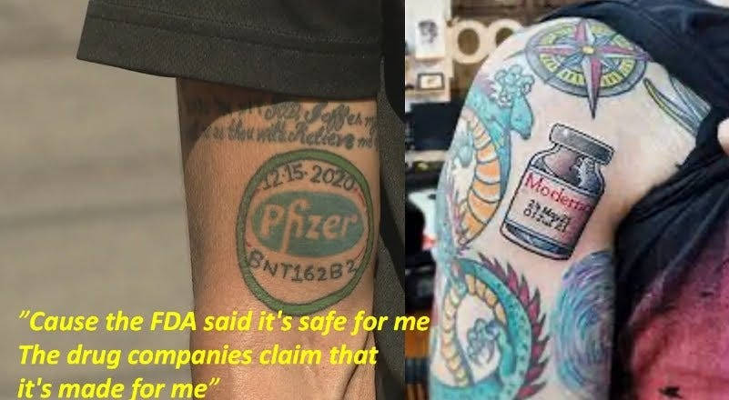

•Justifying censorship since bigoted and unscientific beliefs were deemed equivalent to violence and thus could not be tolerated.

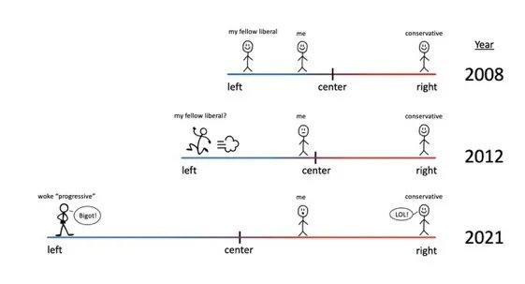

Each of these were the anthesis of the traditional liberal values, but since a remarkable marketing campaign (with Obama as the figurehead) was enacted across the media, it was successful. This in turn led to many (myself included) losing our political home (e.g., the Democrats became no different from the neo-conservatives when it came to pushing disastrous wars overseas). Furthermore, the marketing campaign gradually increased the emotional investment of its audience, so by the time Trump was president, there was a visceral hatred and intolerance to opposing viewpoints.
So, as you might imagine, a wonderful situation was created for the pharmaceutical industry. Supporting the vaccine became a core part of the left’s political identity while any criticism of it was viewed as unacceptable violence against all of society.
Note: one of the first severely injured vaccine patients I came across was a liberal who was one of the people who worked ardently in the PR campaign used to create demand for one of the mRNA vaccines. When I last heard about them from a mutual friend, this individual was still unwilling to acknowledge the vaccine they’d promoted had ruined their life.
Because of this, we now have a situation like the injured hiker described. Questioning the vaccine by admitting you were injured has been deemed the equivalent of committing violence against the society and a clear justification for being cancelled. Many of my patients (and many more of my colleagues), including doctors, have shared that they can’t disclose their injury as if they do, they will be immediately rejected from their tribe and lose the economic status they worked so hard to earn.
One of the best examples I’ve seen of this came from a California physician who shared his experiences treating vaccine injuries with Steve Kirsch and disclosed that he had numerous nurses in his practice who only learned their coworkers had also been injured because they met each other in that doctor’s waiting room. Likewise, a few of my colleagues are treating numerous physicians for COVID vaccine injuries and these physicians have told my colleagues they cannot discuss their injuries with anyone.
Note: from the patients I’ve spoken to, the silencing of vaccine injuries seems to be the biggest issue for individuals working 1) in tech (like the individual mentioned in the tweet) and 2) entertainment (e.g., Hollywood), two industries which are classically predominantly occupied by left-leaning individuals.

Conclusion
One of the most common tactics bad actors use to take control of society is to gradually make questioning their actions socially unacceptable, and then once that becomes normalized, gradually escalate the egregiousness of their behavior. The ancient video I shared above for example illustrates how the Nazis did that—which eventually escalated to the point simply questioning genocide was a crime much of their society agreed should be severely punished.
To prevent escalations like these from happening, it is critical to do everything possible to preserve the right of individuals to question what is happening around them, as without those dissenting voices, the society will gradually get pulled deeper and deeper into whatever scheme the bad actors are creating.
When the vaccines were brought to market, an unprecedented PR campaign was conducted that successfully made much of the population believe the experimental vaccines were essential for ending the pandemic and making things go back to normal. Because of this, many people wanted to do everything they possibly could to dismiss the possibility the vaccines could be hurting people and felt justified doing whatever they could to censor reports it was indeed happening—often even when they themselves were the injured party.
Because that code of silence existed, red flag after red flag was ignored. For instance, before the vaccines came to market, I had a suspicion they might be dangerous and knew a lot of people would ask me about them, so I spent a few hours researching them to have an answer I could provide to patients. After doing this, I saw quite a few things suggesting there would be long-term safety issues with them, was amazed no one else who claimed to be researching them could see this, and moved on to studying something else.
Once the vaccines came to market however, I immediately began seeing a large number of significant reactions I had never seen with any other vaccine and realized I had significantly underestimated how dangerous these injections were. Yet, each time my colleagues (including some who claimed to be very holistic in their approach to medicine) saw the exact same injuries happen, they rationalized some way to dismiss what they were seeing and still push the vaccine on patients who raised questions about those injuries and getting their next shot.
Note: experiencing an injury from the first vaccine has always been one of the most reliable predictors for a severe injury to the second and I got in a lot of hot water for pointing this out at the time when patients asked if they should get the second shot.
Within a few weeks, I started receiving reports of sudden death after vaccination from friends around the country (and heard of a few reports at my clinic—either from relatives of a now deceased patient we’d had lost or from our patients who knew someone it had happened to), but rather than this raising the possibility to my colleagues something might be amiss, it only increased their refusal to discuss anything which might make the public skeptical of the vaccine.
At that point, I realized the scale of what we were up against and began the project that led to me writing here (e.g., through the log I spent a year putting together of everyone I’d come across who’d been injured by the vaccines—which ended up going viral since even a year later reports like that were extremely rare online). As part of that project, I did a much deeper review of all the information that was known about the vaccines prior to them entering the market and once again realized that a huge number of red flags were ignored that should have stopped these vaccines in their tracks long before they hit the market.
Now almost three years later, it seems like the tide is starting to change. A few of the doctors I worked with at the start of the vaccination roll-out were severely injured—to the point quite a few of them (who had been working there for decades) had to leave their positions, and some (but not the majority) of my former colleagues have acknowledged those injuries were due to the vaccine. Similarly, doctors have begun to see so many unusual illnesses and potential vaccine injuries around them that the idea these vaccines are unsafe is becoming a possibility for many (but not all) of them, they are gradually listening to what the dissident doctors are saying and while very few are yet willing to speak openly about it, many will now share their concerns in private to their patients.
In the years to come, the consequences of this disaster will become more and more evident to the public and like many tragedies in the past everyone will likely ask “how could this have happened?” and “what can we do to keep it from happening again?”
I would argue the answers are fairly straight forward:
•Regardless of how much you believe something to be true, you must always be willing to consider the possibility you are wrong. One of the major problems with medicine is that doctors are trained to have such a strong emotional investment in their body of knowledge that it frequently takes them far too long to acknowledge evidence refuting their current (often industry-sponsored) beliefs. Likewise, while people outside the medical community are not subject to as strong a form of mind-control, they still fall prey to this trap since they have been conditioned to associate supporting “the science” with their own intelligence and thus sense of self-worth.
•If you disagree with someone, you must attack their ideas—not the person espousing them. Once it becomes acceptable to attack the person, censorship becomes inevitable, and as the recent events have shown, can rapidly escalate to the point people who are being severely injured or are dying are gagged into silence by their peers—many of whom are well-intentioned people who sincerely believe they are doing the right thing by censoring dissenting viewpoints.
•Recognize that while doing the right thing (e.g., speaking out against the narrative) is often very difficult, the longer you wait to do it, the harder it becomes to do. Because of this, time and time again, we always see the majority of people didn’t speak out, and in hindsight can easily judge them (e.g., “I’d never be like those Germans who let Hitler rise to power”). This should inform each of us that unless we make the point to do something far outside of our comfort zone, each of us will likely make the same mistakes as everyone who came before us.
For these reasons, I always try to speak out on issues I feel are important but almost everyone is ignoring whenever a window emerges where I feel I can effectively open the eyes of those around me. For instance, while I am not opposed to eating meat, I feel the way animals are treated by the industrialized agricultural system is horrific and periodically speak out against supporting the industry—something which also holds true for the innumerable inhumane and uncessessary experiments we perform on animals.
I’ve made it a point to get to know the individuals who can see through the lies everyone else is trapped within and then speak out against them. By doing this for decades, I’ve become able to recognize what the common patterns these people shared were and have been able to both cultivate those traits in myself and encourage them in others (e.g., this article discussed what each of the prominent COVID dissidents had in common with each other).
Because of the elaborate mechanisms those seeking power put in place to eliminate any challenges to their power grab, it can often feel like one is powerless to do anything to challenge it (e.g., this is why it is well known that doctors who seriously disagreed with the prevailing medical dogmas will only challenge them once they are getting ready to retire, as at that point it no longer matters if they lose their licenses). This powerlessness is an awful thing to experience, and many people I’ve spoken to have repeatedly emphasized how much submitting to it gnaws at their soul.
However, even if it’s uncomfortable, there is always a way you can speak out against what is happening without ruining your life in the process. Sometimes it’s not as much as we’d like—for instance almost every prominent COVID dissident I know is very patient and strategic with how they pushed the Overton window (the currently permitted range of discourse).
Nonetheless, it can be done, and since we don’t live in a place like North Korea (where speaking out against the government is immediate grounds for imprisonment or death), it must be done. Furthermore, throughout history, those who did what they could to speak out against what was happening and had that weight lifted off their soul were filled with a strength that allowed them to push forward even in the darkest of times (e.g., the Russian gulags).
Throughout COVID, each of us in turn has had to find a way that we too could speak out against what was happening (e.g., by sharing an article containing a dissenting narrative or having difficult conversations with family members). I feel extraordinarily blessed to have received a way to speak out against what is happening that makes a real impact and I thank each of you from the bottom of my heart for providing the support for this publication that has made made it possible.
The Forgotten Side of Medicine is a reader-supported publication. To receive new posts and support my work, please consider becoming a free or paid subscriber.
Subscribed
This post is public so feel free to share it (e.g., on Twitter).
Share





197 Likes
Comments: 116
Restacls" 15

 | MDJD  3 hrs agoPinned  "Coming out" as vaccine injured sounds much like coming out as gay in the 1980s. It took courage, and damaged relationships, but in the end it was not worth living a lie. The power of so many people telling the truth was that it disrupted false preconceptions most people had about the subject and in time made those preconceptions disappear. As more vaccine-injured people have the courage to speak the truth about their injuries the myth of the "safe and effective" vaccines may also wither. To borrow a phrase from the 1980s, Silence=Death.

 |  | Herb  2 hrs agoPinned  This article like so much of what you write reminds me of the experience that Dr. Nicholas Gonzalez went through with his non-toxic extraordinarily effective protocol for curing all types of cancers.  I was his patient for 25 years before he passed away having originally seen him when I had a bronchial cancer that metastasized to the liver in 1989 that his protocol quickly cured.  All he ever wanted to do was to test his protocol against standard cancer treatment. He got his wish even though it turned out to be a nightmare when the NIH funded a trial comparing his protocol to chemotherapy around the year 2000.  Having been previously a journalist he wrote a 700 page book ‘What Went Wrong’ how big Pharma and big academic medicine conspired to corrupt the trial to demonstrate that has therapy was not effective.  I was reminded in reading your story about a conversation I had with him one day when I asked him whether any well-known people in politics, the media or Hollywood were his patients.  He indicated that quite a number were and yet not one of them was willing to go public because they were afraid of being ridiculed and worse.  They were all so averse to publicity that Nick had to come into the office on Saturday to treat them so no one would be in the building who could recognize them.  (He also told me about a long conversation he had with Steve Jobs after Jobs contracted pancreatic cancer about his protocol. He realized as the conversation went on that Steve was convinced that he knew as much about cancer and health as he did about computers and phones and so he decided to pass up on being a Gonzalez patient. Had Steve decided to be a patient and been willing to tell the public the world would be very different and much better these days.)  If even one or two of them had been willing to go public with their incredible success stories it might’ve changed everything and the Gonzalez protocol would be an accepted if not preferred part of cancer treatment.  The social pressure to conform, the fear of losing status, position and income are incredibly powerful forces to enforce a status quo that brings such unnecessary harm and suffering to millions as you eloquently describe.  Your writings and your work are so important that I can only hope that someone somewhere in a position of power and influence will hear about them and act accordingly.  LIKE (11)

